Customer Types

Basic Rules:
- Only 3SquaresVT/SNAP benefit recipients can receive Crop Cash.
- An individual must spend their 3SquaresVT/SNAP benefit to receive Crop Cash or Crop Cash Plus (CC+).
- Anybody who gets Crop Cash should get $1 tokens for their 3SquaresVT/SNAP purchase.
- May 1, 2023 - October 31, 2023 only: Anybody who gets Crop Cash should also get CC+ to spend on any SNAP-eligible item. (Exception to time limit: EBT Cash / direct deposit customers will continue to receive CC+ from May 1, 2023 - April, 2024).

EBT Food Customer | 1.  2.  3.  4. | Customer swipes EBT/P-EBT card as EBT Food.  Manager gives them a corresponding amount of $1 tokens.  Manager matches purchase dollar for dollar with Crop Cash, up to $20.  May 1, 2023 - October 31, 2023 only: Manager also matches purchase dollar for dollar with CC+, up to $20.
Senior or Disabled Adult  Direct Deposit Customer | 1.  2a.  2b.  2c.  3. | Customer comes to market with Cash, Check, or Debit and states that they receive their 3SVT benefit directly deposited in their bank account. These customers may not have proof that their benefits are deposited directly into their bank account. They can still participate in the program as long as they purchase $1 tokens.  Cash Purchase: Manager gives them a corresponding amount of $1 tokens in exchange for cash.  Check Purchase: Manager accepts check and gives them corresponding amount of $1 tokens.  Debit Purchase: Manager swipes card as debit and gives them corresponding amount of $1 tokens.  Manager matches 3SVT purchase with *two times* the amount of CC+, up to $40. No Crop Cash is given.
EBT Cash 3SVT Customer | 1.  2.  3.  4. | Customer states that they receive their 3SVT benefit deposited as EBT Cash.  Customer swipes card as EBT Cash.  Manager gives them corresponding amount of $1 tokens.  Manager matches 3SVT purchase with *two times* the amount of CC+, up to $40. No Crop Cash is given.  *NOTE:

EBT Card
EBT Food Customer
- Receives their 3SquaresVT/SNAP benefit on their EBT or P-EBT card
- Benefit deposited as EBT Food or EBT FS (depending on type of card machine)
- Receive $1 tokens for their EBT Food purchase
- Eligible to receive Crop Cash and CC+
- Receive Crop Cash as dollar-for-dollar match for 3SquaresVT/SNAP purchase, up to $20
- Receive CC+ as dollar-for-dollar match for 3SquaresVT/SNAP purchase, up to $20 (May 1, 2023 - October 31, 2023 only)

EBT Cash 3SVT Customer
* EBT Cash (as opposed to EBT Food) customers may no longer receive Crop Cash. However, if they tell you that they receive their 3SquaresVT benefits as EBT Cash, they may receive CC+ at a double-matching rate, up to $40.
Markets should not assume that all EBT Cash users are eligible to receive CC+. In order for EBT Cash customers to be eligible for CC+, they must indicate to market staff that they receive their 3SquaresVT benefit as EBT Cash.
If a customer is using EBT Cash that is a benefit other than 3SquaresVT (food benefits), they should receive $5 tokens, and no Crop Cash or CC+.
- Receives their 3SquaresVT/SNAP benefit on their EBT card
- Benefit deposited as EBT Cash
- Receive $1 tokens for their EBT Cash purchase
- Eligible to receive CC+, but not Crop Cash
- Receive CC+ as double-for-dollar match for 3SquaresVT/SNAP purchase, up to $40

Other
Senior/Disabled Adult Direct Deposit Customer
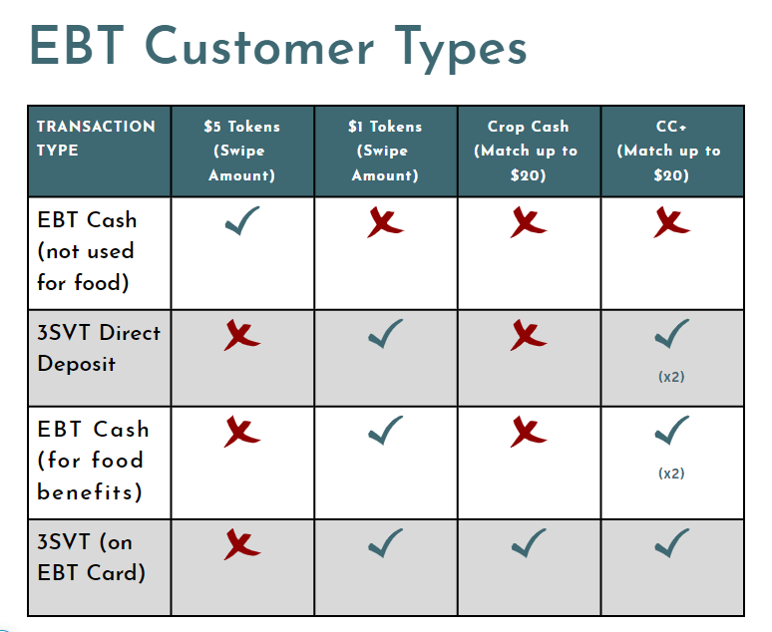
* In order for these customers to be eligible, they must indicate to market staff that they receive their 3SquaresVT benefit directly deposited in their bank accounts. These customers will not have an EBT card.
- Receives their 3SquaresVT/SNAP benefit directly deposited into their personal bank account
- Pay with Debit, Cash, or Check.
- Receive $1 tokens for their purchase.
- Eligible to receive CC+, but not Crop Cash.
- Receive CC+ as double-for-dollar match for 3SquaresVT/SNAP purchase, up to $40.

