2022-23 REPORTING & REIMBURSEMENT SCHEDULE
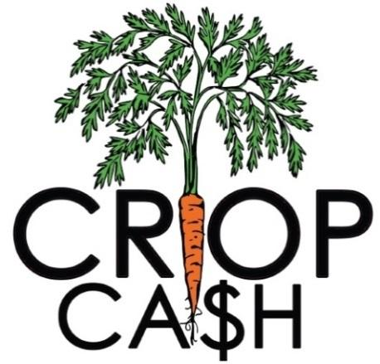
DATA ENTRY DEADLINES: SUMMER SEASON (May 1 – October 31)
Date | Requirement
June 7 | Enter data from May 1st – 30th
July 7 | Enter data from June 1st – 30th
August 7 | Enter data from July 1st – 31st
September 7 | Enter data from August 1st – 31st
October 7 | Enter data from September 1st – 30th
November 10 | Enter data from October 1st- 31st  End-of-Season Reporting Requirements Due

DATA ENTRY DEADLINES: WINTER SEASON (November 1 – April 30)
Date | Requirement
December 7 | Enter data from November 1st – 30th
January 7 | Enter data from December 1st – 31st
February 7 | Enter data from January 1st – 31st
March 7 | Enter data from February 1st – 28th
April 7 | Enter data from March 1st – 31st
May 10 | Enter data from April 1st - 30th  End-of-Season Reporting Requirements Due

REIMBURSEMENT SCHEDULE
Unless otherwise arranged with NOFA-VT, markets will be reimbursed on a set schedule. To receive reimbursement by the dates set below, your market must submit market data onto FM Tracks by the deadline listed above. Failure to submit reporting requirements by the set deadline will result in delayed reimbursement.
Date | Reporting Period
July 21 | Reimbursement for June 1 – June 30
September 21 | Reimbursement for July 1 – August 31
November 21 | Reimbursement for September 1 – October 31  FINAL REIMBURSEMENT FOR SUMMER CROP CASH
January 21 | Reimbursement for November 1 – December 31
March 21 | Reimbursement for January 1 – February 28
May 25 | Reimbursement for March 1 – April 30  FINAL REIMBURSEMENT FOR WINTER CROP CASH

